*LAB#01*

*Fundamentals of Web Development & Web Designing*

**OBJECTIVE:** Learn and Understand Web Development & Web Designing

***STUDENT TASK:***

* **Pages to Create:**
* **Index Page:**

* **LOGIN PAGE**

* **Register page**

* **CSS STYLE**

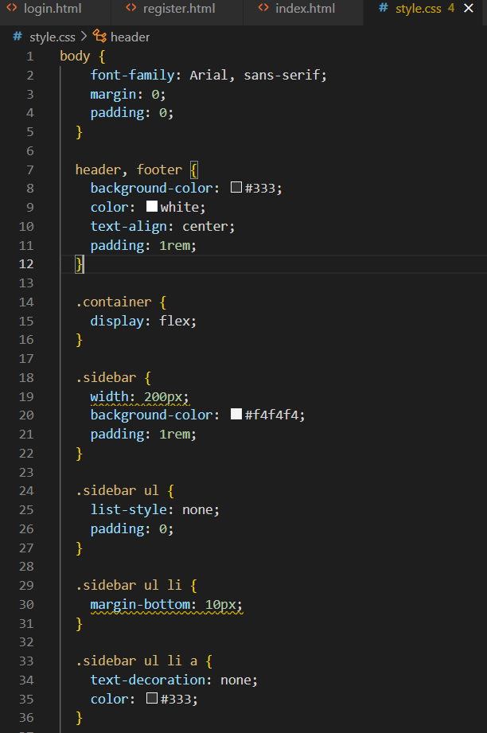

# Hands on Practice Task (Optional)

Create a personal portfolio website using **HTML & CSS**. Your portfolio should include the following sections:

* 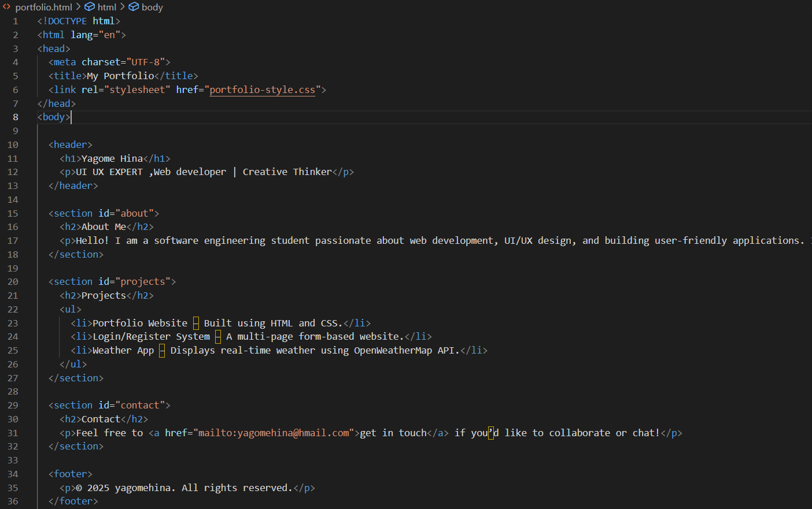**portfolio.html**
* **portfolio-style.css**
* A screen shot of a computer program

  AI-generated content may be incorrect.**A screen shot of a computer program

  AI-generated content may be incorrect.**
* ***PORTFOLIO***

